**AWS Lambda Assignment**

**Naman Moolri CEQ-525**

1. **Create lambda function that will trigger when an object is uploaded in S3 bucket. Create a new bucket and upload the same object (used for triggering) in new bucket using boto3.**

**Steps to Create AWS Lambda Function:**

1. Go to lambda.
2. Clink on Create function.
3. Select Author from Scratch
4. Give name to function.
5. Provide Runtime ex. Python or Ruby etc. according to your requirements
6. Select architecture.
7. Permissions
8. Change default execution role.
9. Advance settings (enables tags)
10. Click on create function.

Now our function is successfully created.

**Steps to Create S3 Bucket:**

1. Go to S3
2. Click on Create Bucket button.
3. Give name to Bucket.
4. Select Object Ownership
5. Uncheck Block all public access box.
6. Select Bucket Versioning
7. Add Tags
8. Finally, Click on Create Bucket Button.

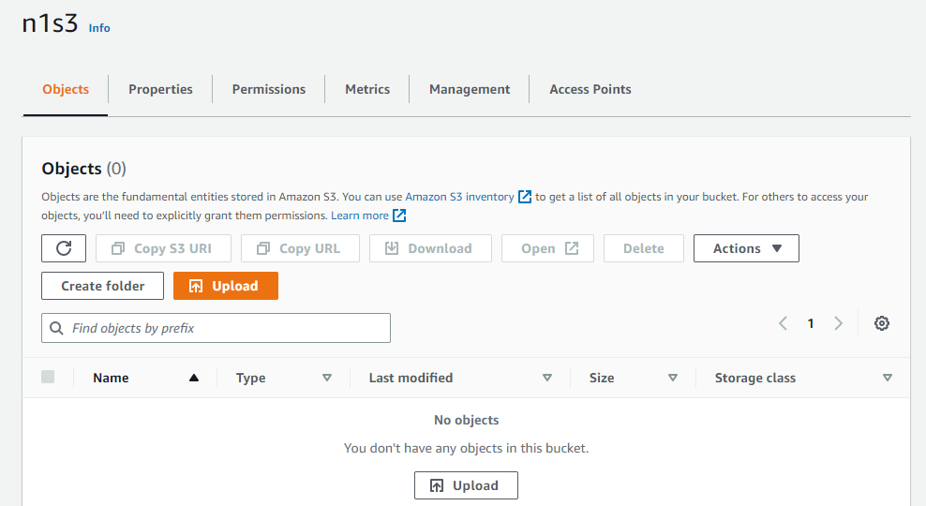

**Steps to add S3 Bucket in Lambda Function:**

1. Click on add Trigger Button.
2. Select Source Type
3. Give Bucket Name
4. Select Event Type
5. Check Recursive invocation acknowledge box.

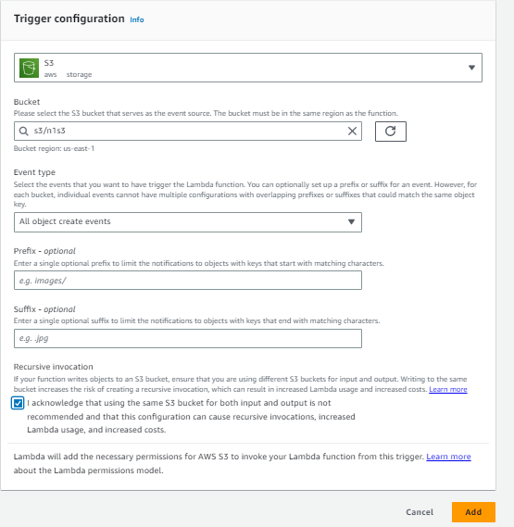

**Add Object to S3 Bucket:**

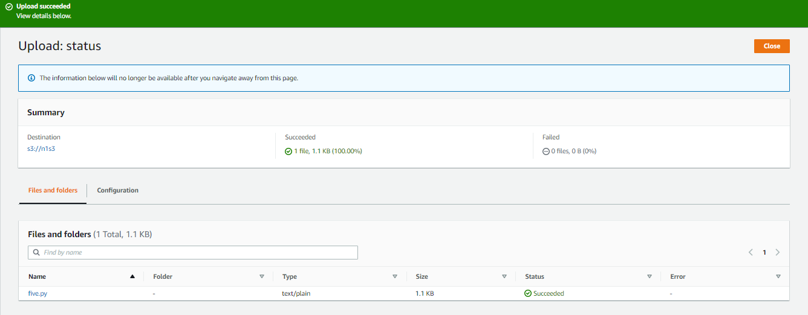

**Add Second S3 Bucket in Lambda Function:**

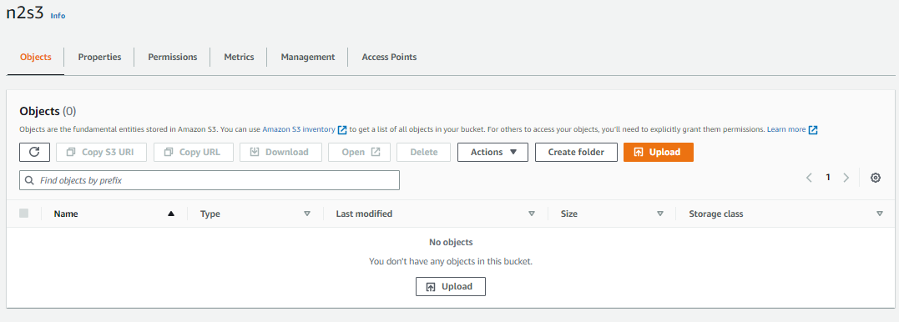

**Add same object in new Bucket using Boto3:**

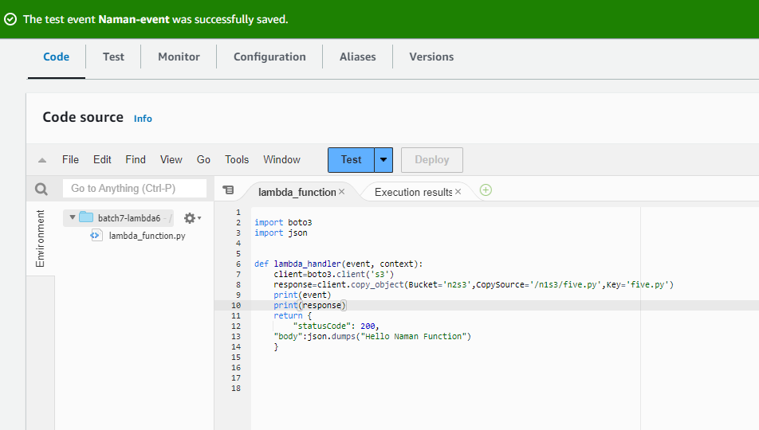

**Result:**

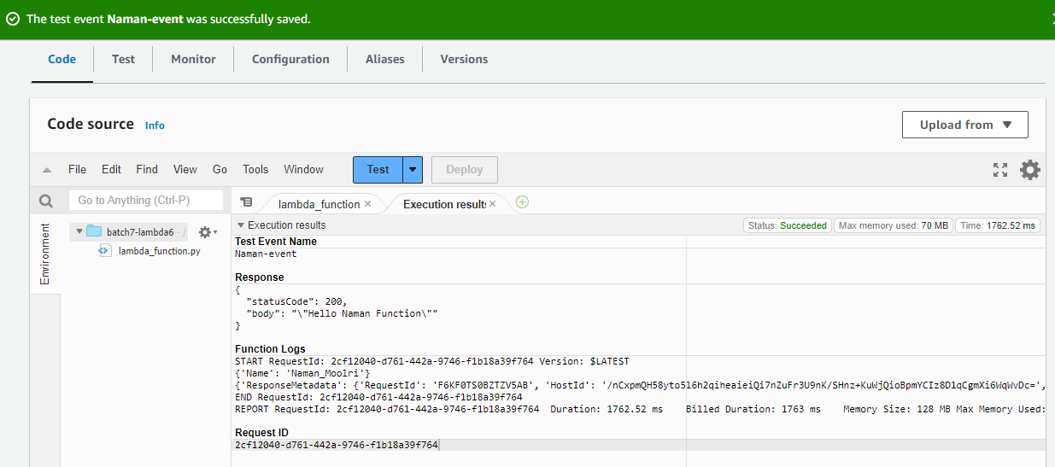

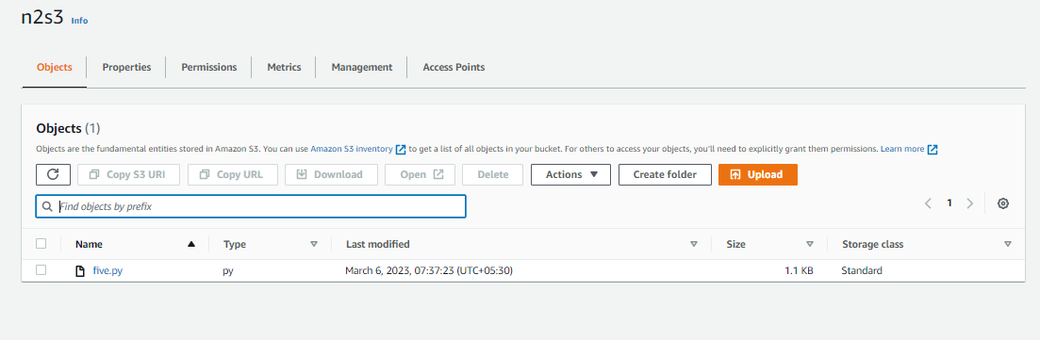

**2. Create a lambda function which will invoke another lambda function.**

1. Create (Batch-7-lambda6) and (batch-7-lambda4) function.
2. Add triggers in both functions.
3. Call (batch-3-lambda4) function inside (batch-7-lambda3) function.

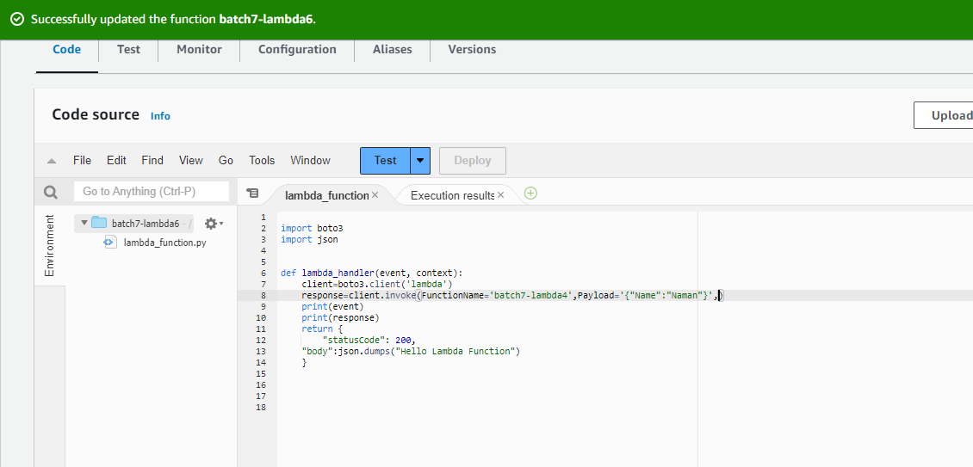

**Output:**

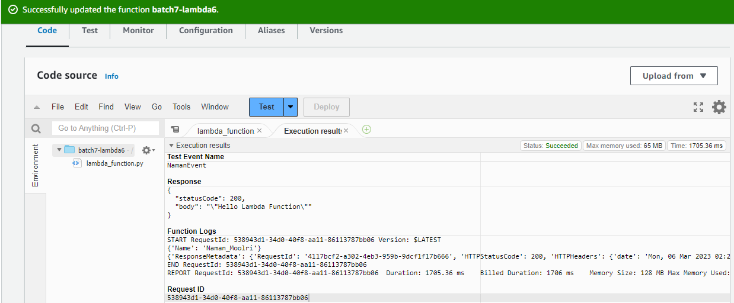

**Logs Groups Output:**

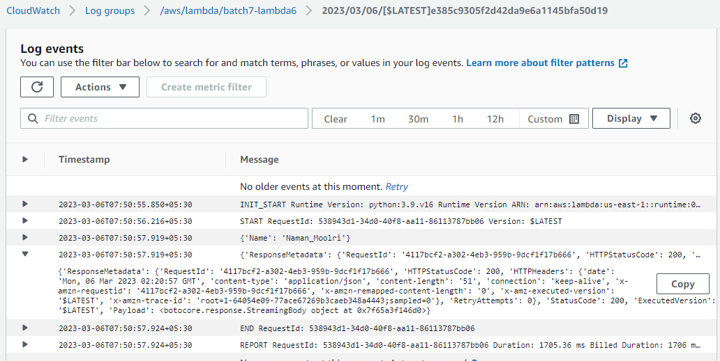

**Second Lambda Function Logs Group Output:**

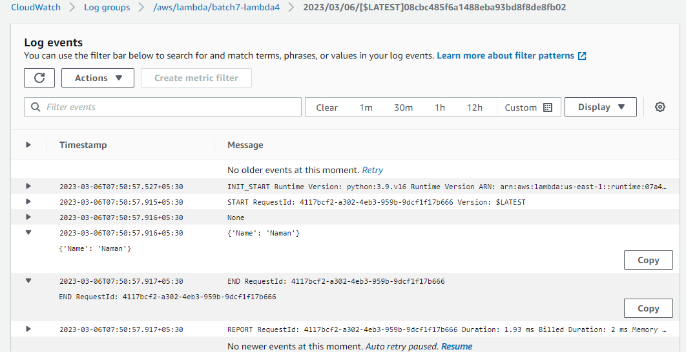

**3. Create a lambda that will have 2 triggers:**

1. **When object is uploaded in s3 bucket and**
2. **When object is deleted from s3 bucket. And have SNS as destination and the result should display only the bucket name.**

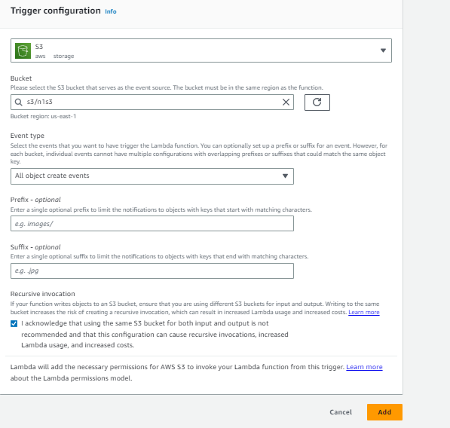

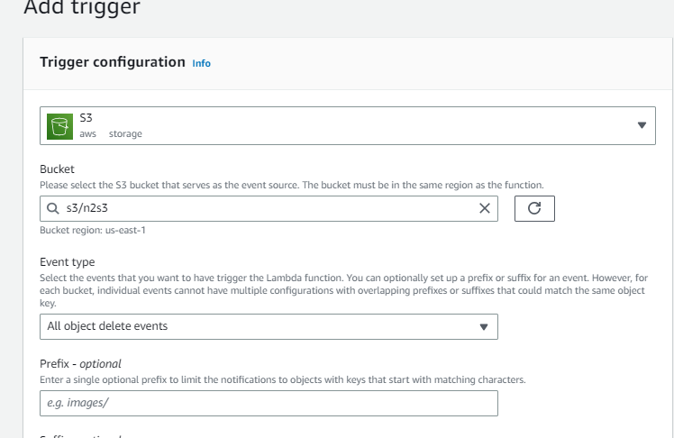

**Add Topics:**

1. Go to SNS Services
2. Click on create topics.
3. Select Standard type.
4. Give Topic name.
5. Add Tags

Finally, click on Create Topic Button. Now, successfully your Topic is created.

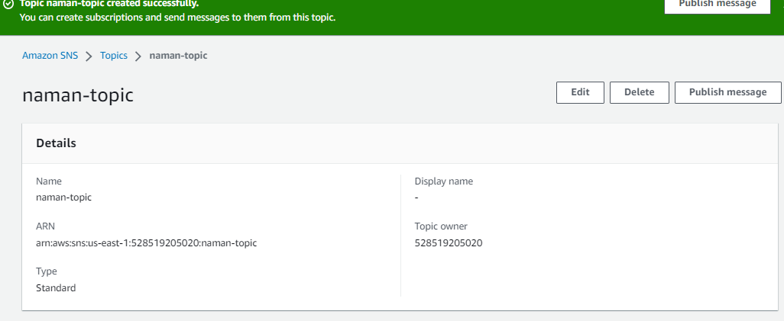

**Add Subscription:**

1. Topic ARN (topic name)
2. Select protocol.
3. Now, create on subscription button.
4. Now, you got an Email on your mail id for confirmation.

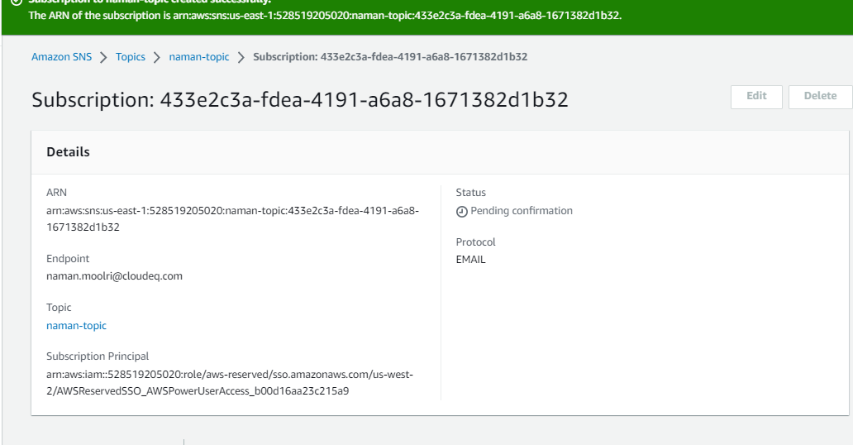

**Subscription Confirmation:**

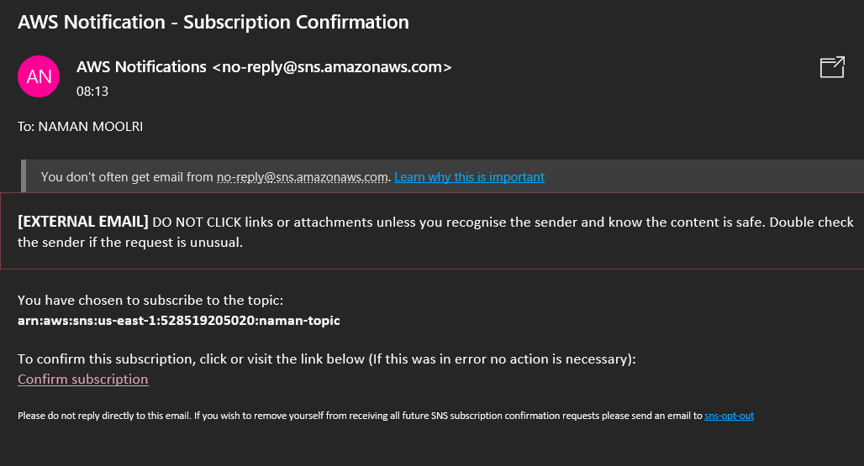

1. Now, Click on Confirm Subscription.

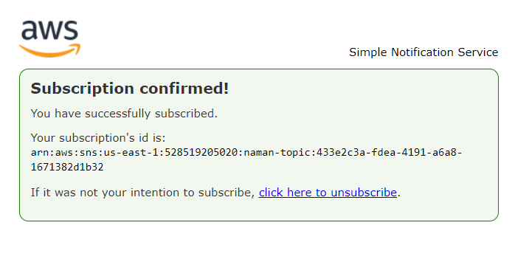



**Adding file in S3 Bucket using SNS**

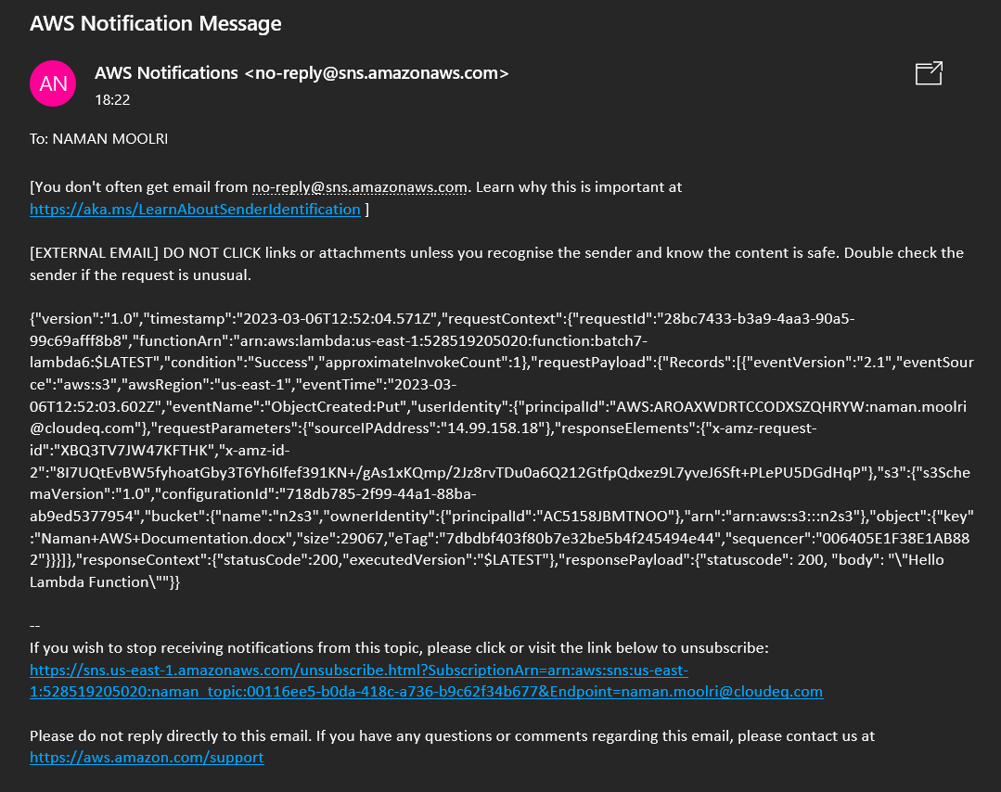

**Deleting file in S3 Bucket using SNS**

